Evidence for the PDA in software development

P - Planning Unit

Benjamin Bowen - Cohort E17

P1

Take a screenshot of the contributor’s page on Github from your group project to show the team you worked with.



P2

Take a screenshot of the project brief from your group project.

The group used the given project brief:



P3

Provide a screenshot of the planning you completed during your group project, e.g. Trello MOSCOW board.

This is the group’s Trello board during the project:

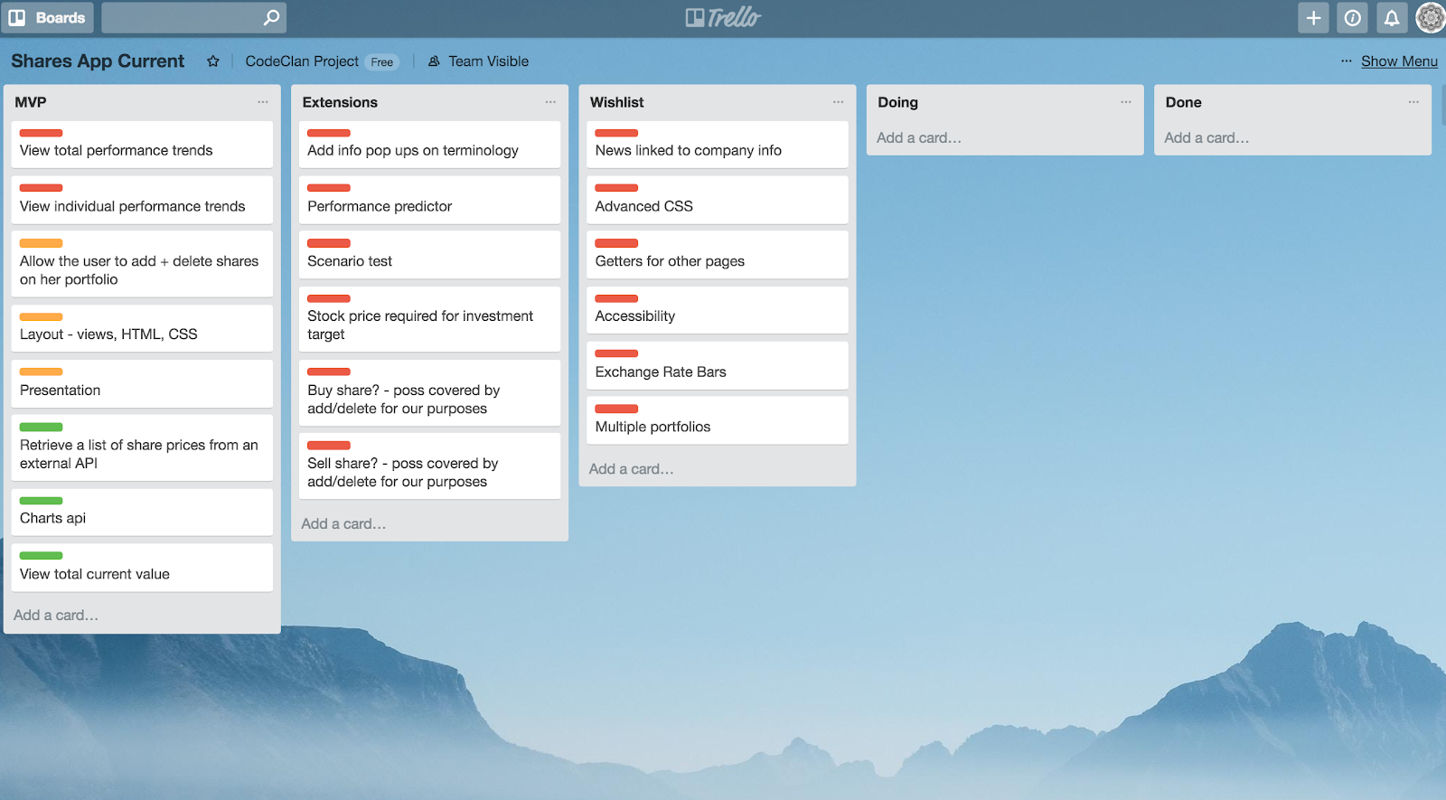

The is the Trello board at the end of the project:

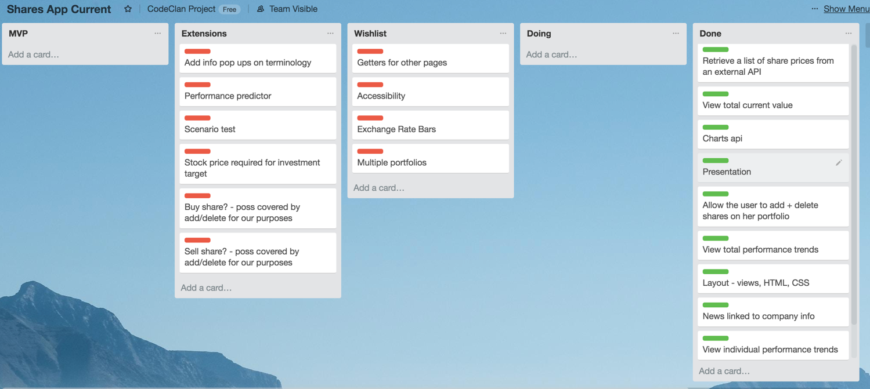

P4

Write an acceptance criteria and test plan.

This is for the group project ‘Peak Portfolio’.

|  |  |  |
| --- | --- | --- |
| Acceptance Criteria | Expected Result/Output | Pass/Fail |
| A user is able to record transactions of shares (both buying and selling). | When the add shares button is clicked a modal box opens with a search box for company and text box for inputting the price of share | Pass |
| A user is able to view the total, up to date, portfolio value | When the app loads this is shown clearly at the top of the page. This displays with the prices of each share using the latest value on alphavantage | Pass |
| A user is able to view a chart showing the breakdown of the values of shares in the portfolio. | A pie chart is displayed showing the breakdown of the total portfolio value for each share. | Pass |
| A user is able to view the trend of the value of the whole portfolio | A line chart is displayed at the bottom of the page showing the historical value of the portfolio. | Pass |
| A user is able to find news information relating to an individual share | A user can click on the name of a share in the table showing all their shares and is taken to a new page showing links to news stories related to that share | Pass |

P5

Create a user site map

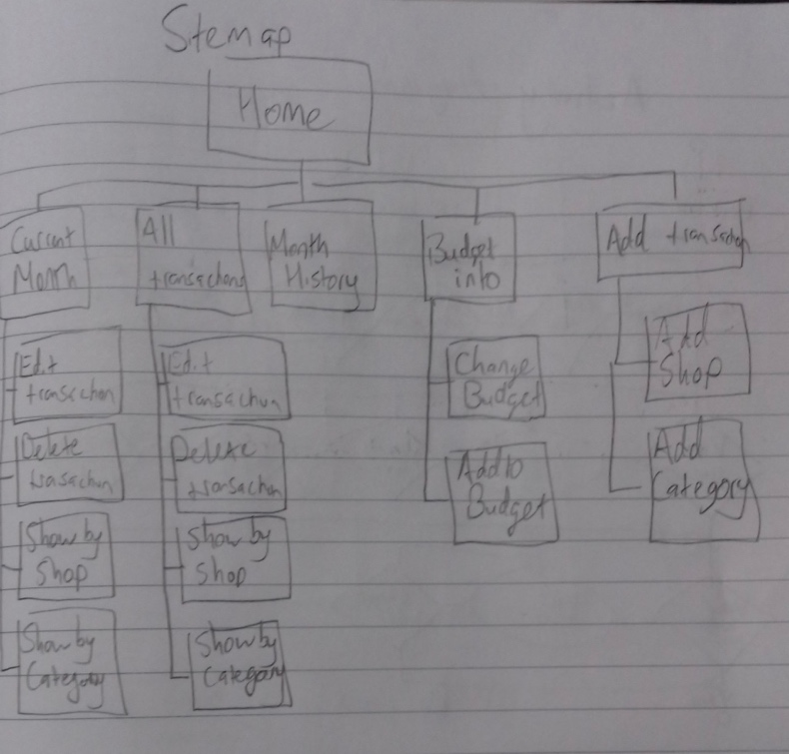

P6

Produce two wireframe designs

Wire frame diagram for my app’s homepage

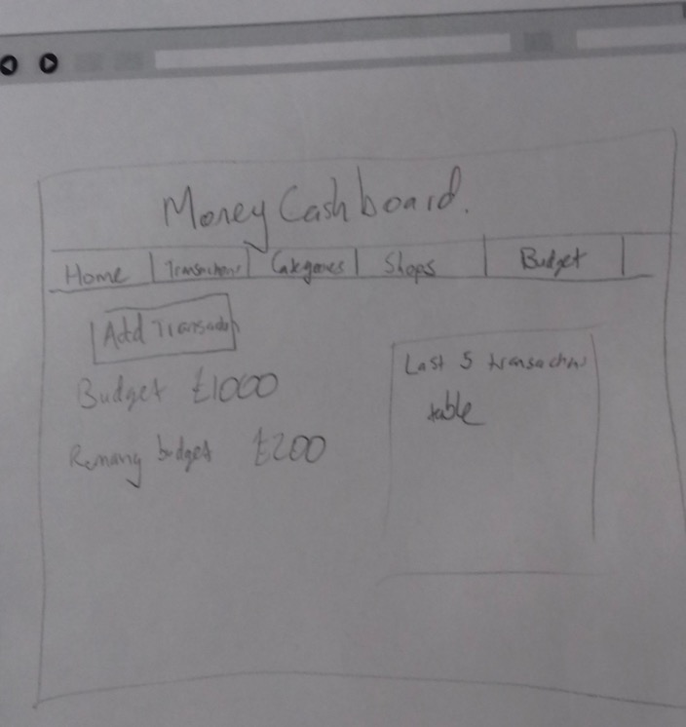

Wire frame diagram for the transactions page.

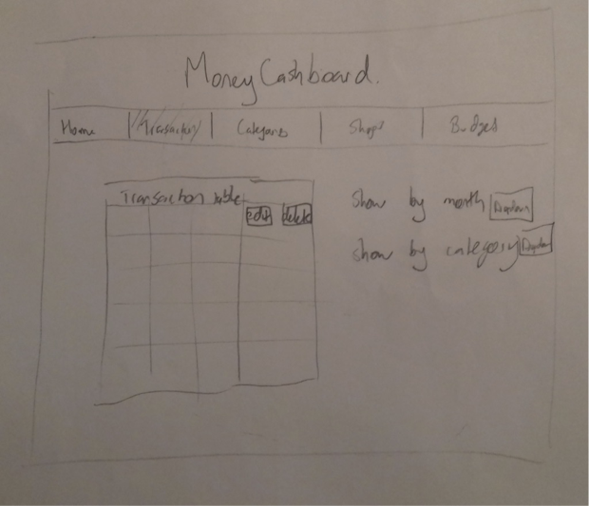

P7

Produce two system interaction diagrams (sequence and/or collaboration diagrams).

Viewing the total portfolio value (from JavaScript project)



Saving a transaction to the database (from Ruby project).



P8

Produce two object diagrams.

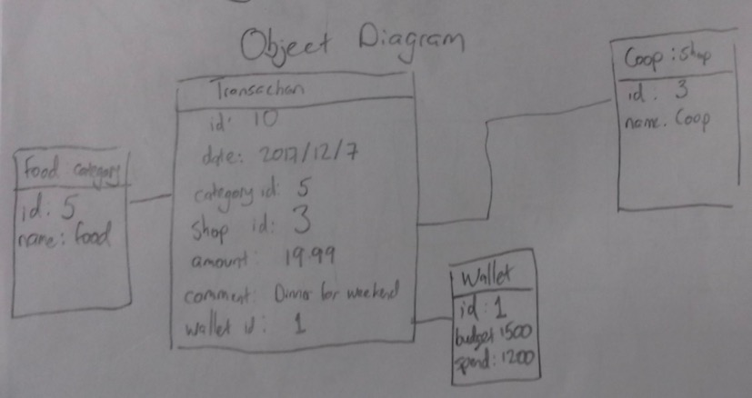

P9

Select two algorithms you have written (NOT the group project). Take a screenshot of each and write a short statement on why you have chosen to use those algorithms.

This algorithm written in javascript calculates the number of dinosaurs there will be in the park for a given number of years in the future. I used this algorithm as each dinosaur in the park needs to be considered as they have different offspring rates. If a dinosaur has an offspring rate of 4, after a year the expected number of dinosaurs is the four offspring plus the original dinosaur. This is raised to the power of the number of years as each of the offspring will themselves produce offspring.



This algorithm removes all the dinosaurs of a given type by filtering all dinosaurs so only those not equal to the given type are put in an array. The dinosaurs you don’t want have therefore been removed. The enclosure content is then set to this new array.



P10

Take a screenshot of an example of pseudocode for a function.

This is the pseudocode and java code for the move forward one step method of a robot. The robot is on a two dimensional (x,y) grid, and has an orientation, the direction it is facing, in addition to the initial position.



P 11

Take a screenshot of one of your projects where you have worked alone and attach the Github link.

This is a ruby, sinatra, sql, html and css project. I built a money tracking app:

<https://github.com/benjaminbowen00/ruby_sql_sinatra_project>

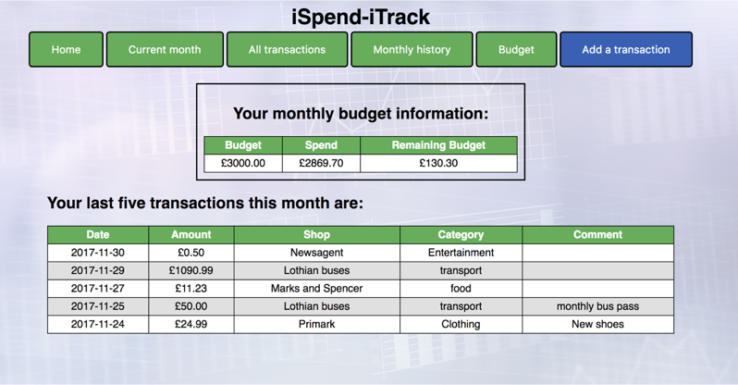

P 12

Take screenshots or photos of your planning and the different stages of development to show changes.

Class diagrams. Initially the date was saved only as string, but this was later changed to a DateMonth object so that only transactions from the last six months could be shown:

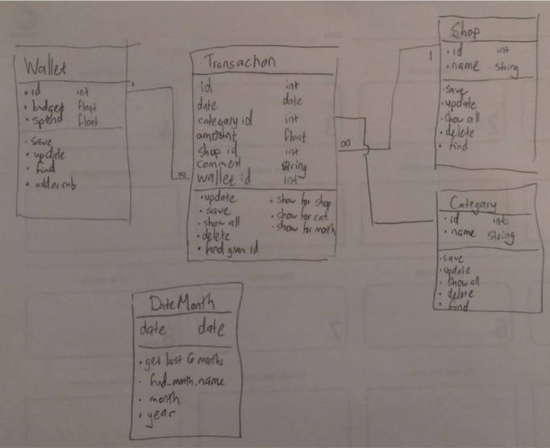

Planning the user needs for the app:

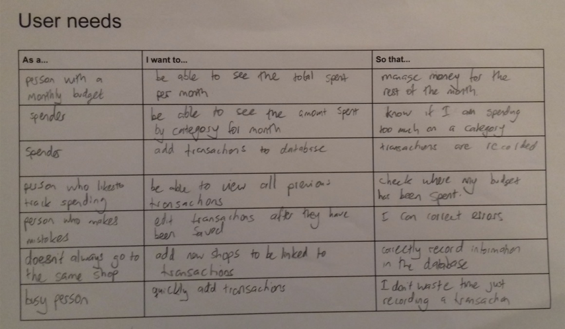

An example of a user journey from the planning of the project:

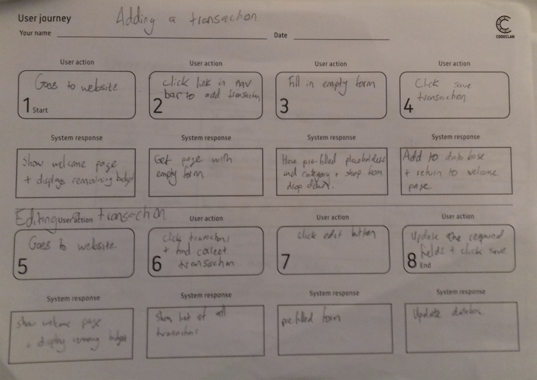

P13

Show user input being processed according to design requirements. Take a screenshot of:

* The user inputting something into your program
* The user input being saved or used in some way

The monthly budget was initially £1600:

The user inputs the new budget of £1500:

This new budget is then saved and displayed on the budget information page. The remaining budget is now £100 lower than before:

P14

Show an interaction with data persistence. Take a screenshot of:

* Data being inputted into your program
* Confirmation of the data being saved

A new transaction is added through completing the form which saves the record to the database:

This is then visible on the monthly transactions page:

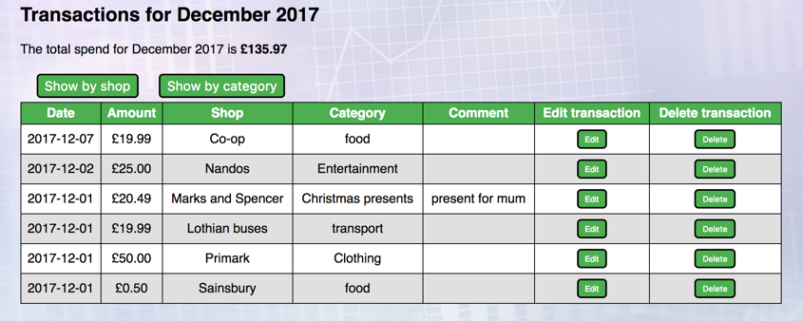

P15

Show the correct output of results and feedback to user. Take a screenshot of:

* The user requesting information or an action to be performed
* The user request being processed correctly and demonstrated in the program

The user selects to view the transactions for November 2017 - the button changes colour when the mouse hovers over it.



The page showing the transactions for November 2017 is returned:



P16

Show an API being used within your program. Take a screenshot of:

●  The code that uses or implements the API

●  The API being used by the program whilst running

An HttpXML request is made and the result is set in the state as ‘records’. The records are sent to the ChartList as props:



The ChartList component renders a div of records with props being sent to each Record:



The Record component renders the information to be displayed in the app.

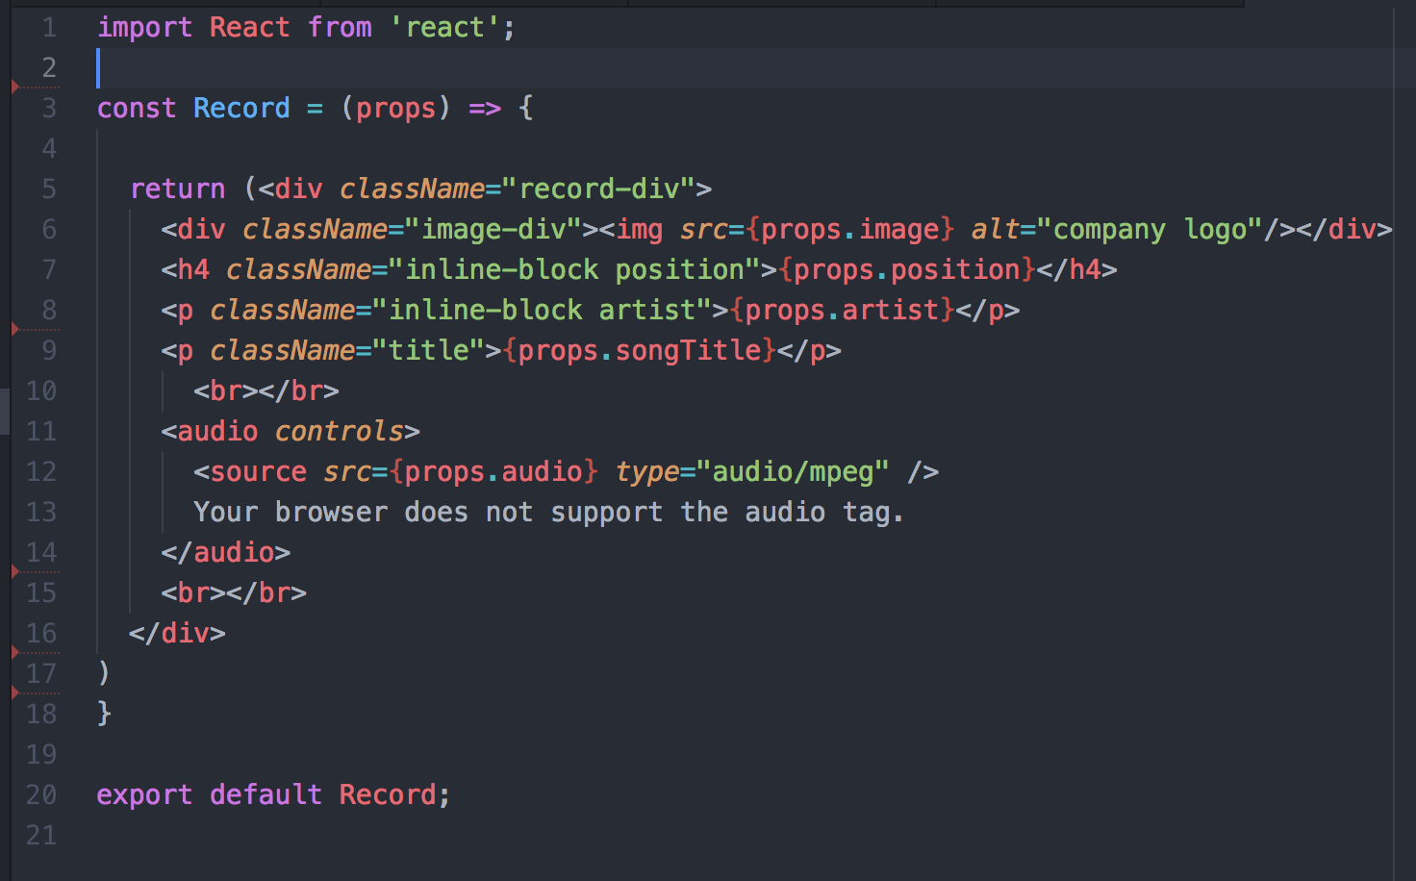

The resulting app looks like this:



Here is the start of the API being used:

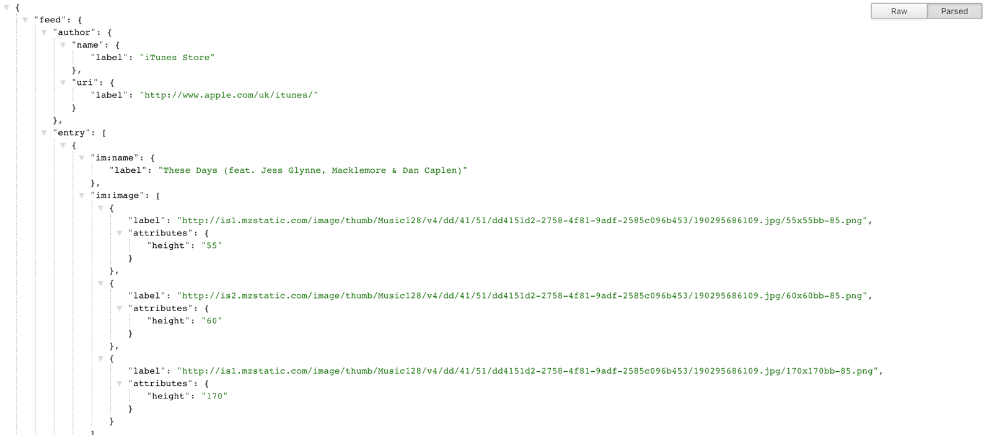

P17

Produce a bug tracking report:

For my android food tracking app:

|  |  |  |  |
| --- | --- | --- | --- |
| User can record the date for when they ate the food. | Fail | Use android’s datePickerDialog to display a calendar the user can select from | Pass |
| The meal for a food must be of only pre-set values | Fail | Use a spinner that is filled with values from an enum rather than text input. | Pass |
| An empty page is not displayed if no results for food by date/meal type/search | Fail | If the array formed from the database search is of size zero then display a message to say there were no results found for the criteria | Pass. |
| Whole database of foods can be cleared | Fail | Create a new activity with a button linked to a Dao that does a ‘DELETE FROM foods’ on the database | Pass |
| User can view foods for a particular date | Fail | Create a new activity with a datePickerDialog to select the date and then run a Dao which does a ‘SELECT * FROM foods WHERE date = :dateString’ where dateString is taken from the datePickerDialog. | Pass |

P18

Demonstrate testing in your program. Take screenshots of:

●  Example of test code

●  The test code failing to pass

●  Example of the test code once errors have been corrected

●  The test code passing

A food object has an attribute of poisoned that is initially set to false:



A test is written in mocha so that a Rat object can change the poisoned attribute of a Food object to true:

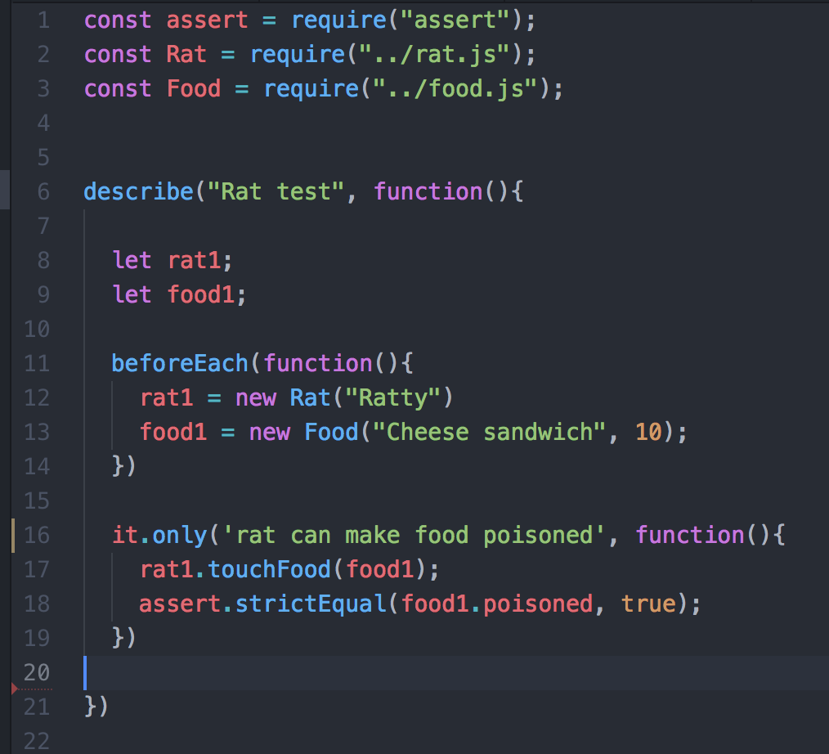

The test is run but fails because the method has not been written yet:

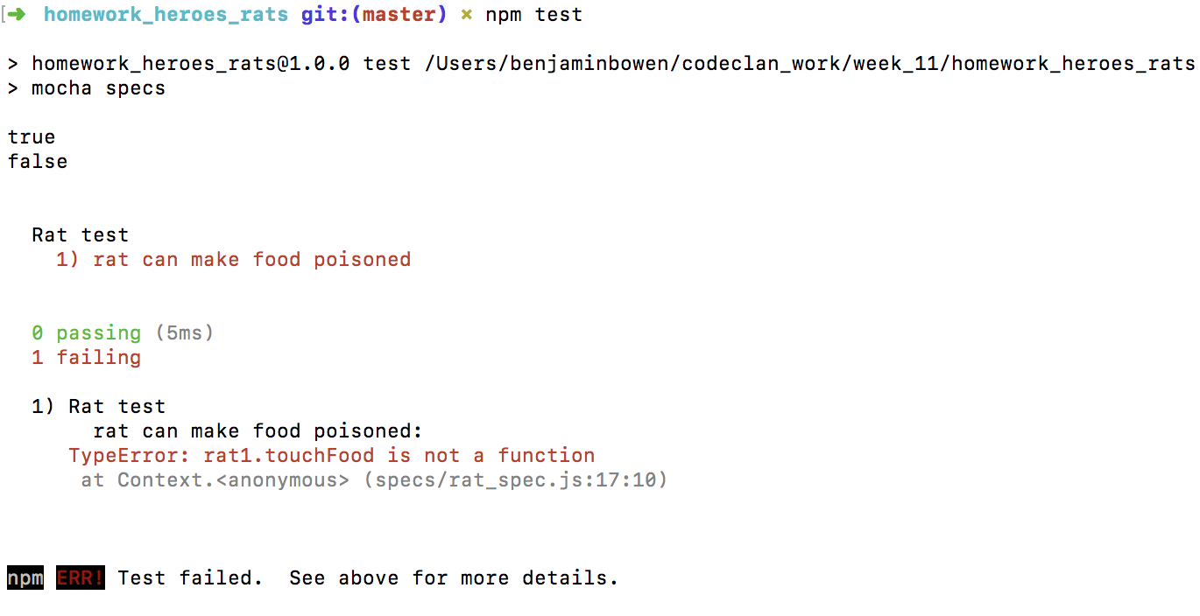

The ‘touchFood’ is added as a Rat method.



The test is now re-run and passes as food1’s poisoned attribute has been changed to true:

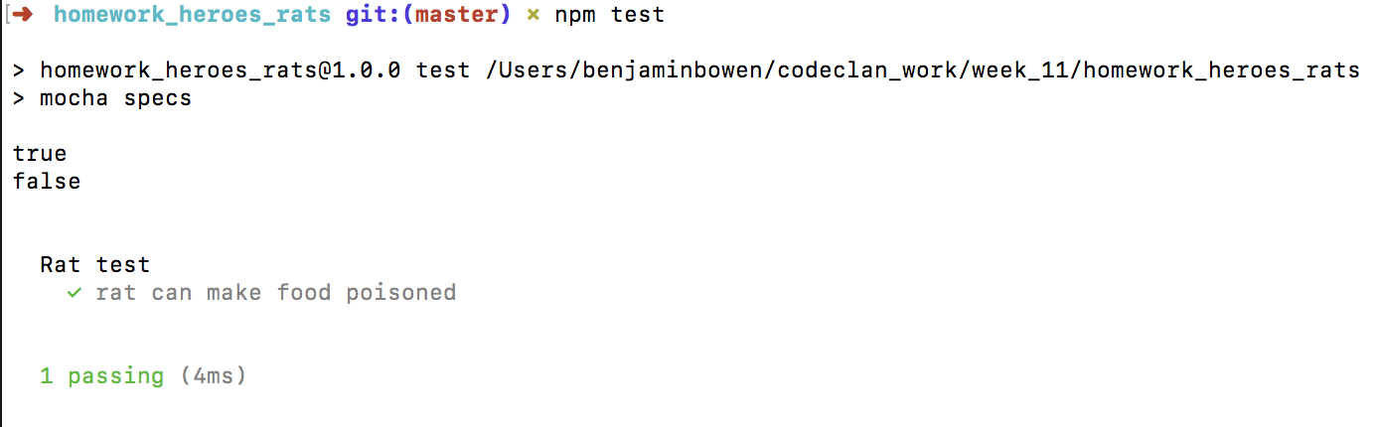

Here are tests for Food being compared to each other based on having the same name:



Initially they fail:



The equals() method is added to the Food prototype, which converts the food name to lower case and then compares them:



The tests now pass:

